App-server Web-server Task : mohammed mujahed-batch-16
- Install nginx and run nginx on port number 81.
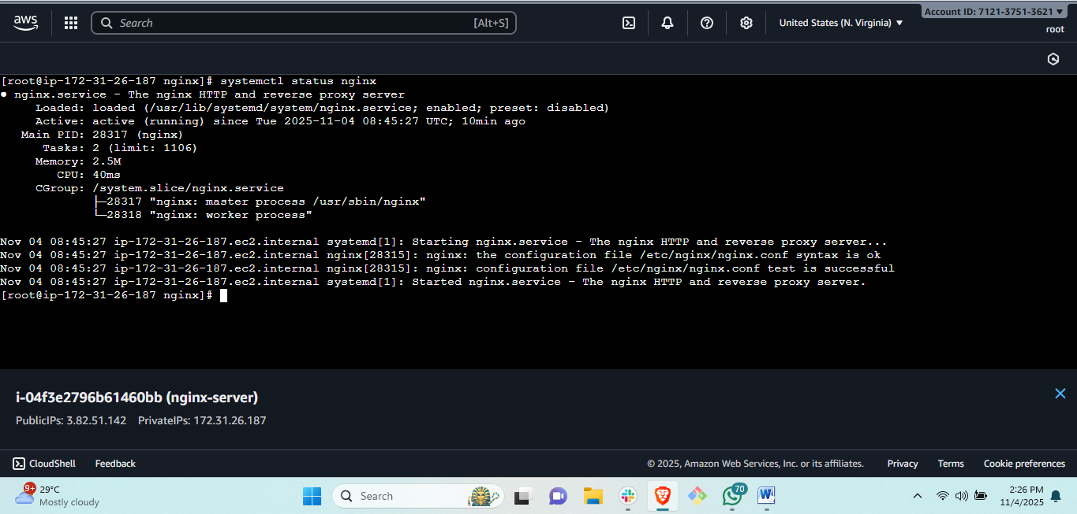
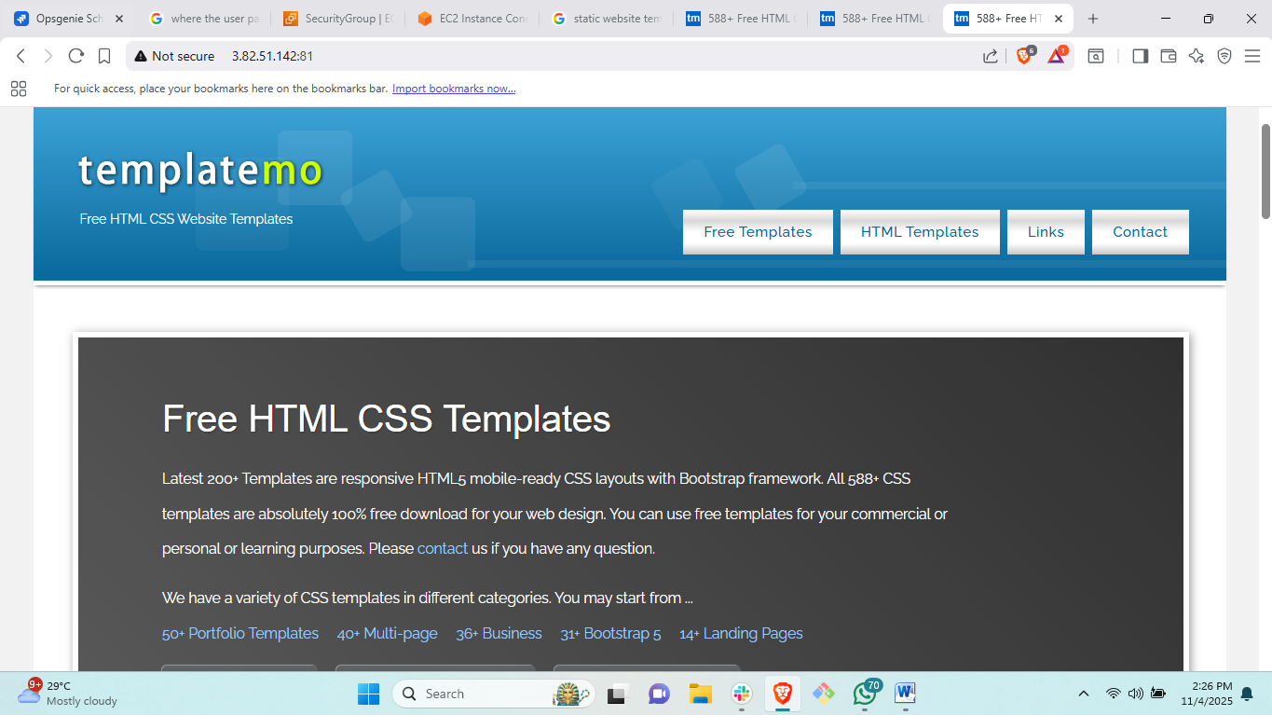
Steps: first setup nginx:<yum install nginx>
#then <syatemctl start nginx>
#then do to browser and copy link address of satic website link address.
# then <vi /usr/share/nginx/html/index.html> create new index.html file and run
#to change the port number<vi /etc/nginx/nginx.conf>
# Go security credential and edit security inbound. Add all traffic.
#check for the result by paste the public ip:81.
- Deploy a sample index.html file on nginx.

Steps:#to deploy the content on website<cd /usr/share/nginx/html>
#there will be a index.html file delete this file <rm –rf index.html>
#go to browser and copy link address of template
#then download this <wget “URL”>
# change the name of file <mv downloades file name to index.html>

- Install Apache and run Apache on port number 82

Steps: # to install httpd<yum install httpd>
#start httpd<syatemctl start httpd>
#change port number<cd /etc/httpd/>
#<vi httpd.conf> change the port number to 82.
- Deploy a sample index.html file on Apache.

Steps: to deploy a sample file go to browser and copy link address of template.
# cd /var/www/html
# download the link <wget URL>
#rename the downloaded file to index.html<mv file name to index.html>
#<systemctl restart httpd>
- Install Apache tomcat on port number 8082
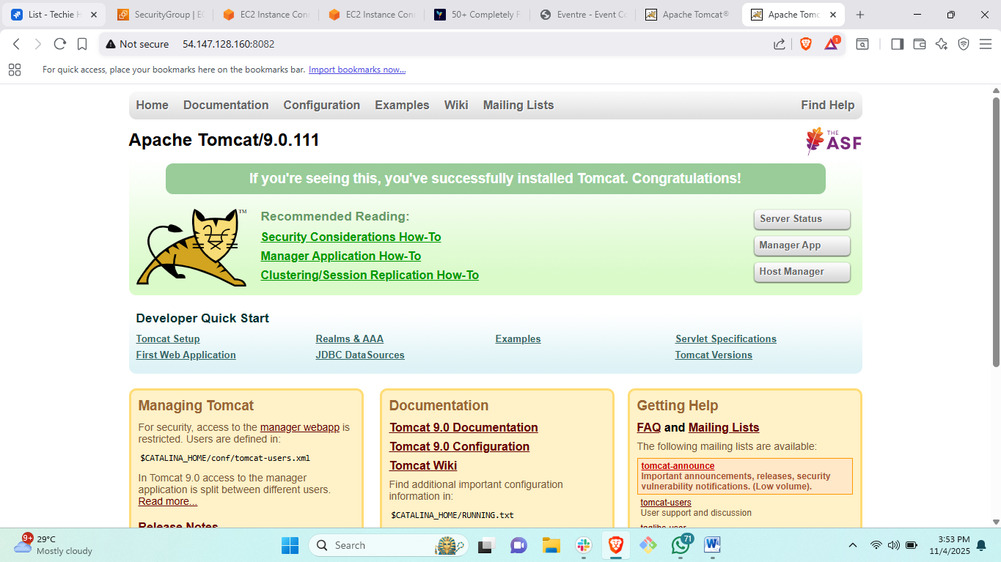
Steps: followed the same route as did in task 42
# to change the port number of apache tomcat <cd /tomcat/conf/>
#edit the file <vi server.xml> change port from 8080 to 8082.
- Deploy a sample app on webapps.
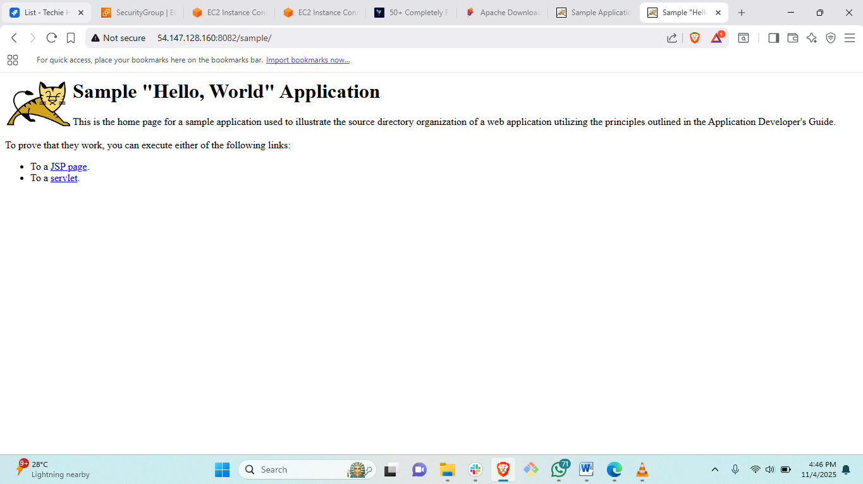
Steps: go to browser and search apache tomcat sapmple.war
#then copy link address
#go to <cd /opt/tomcat/webapps/>
# then wget URL
# <ll> and again <ll>
#go to browser paste your public ip:8082/sample. To check status.
- Create a tomcat.service file for tomcat.
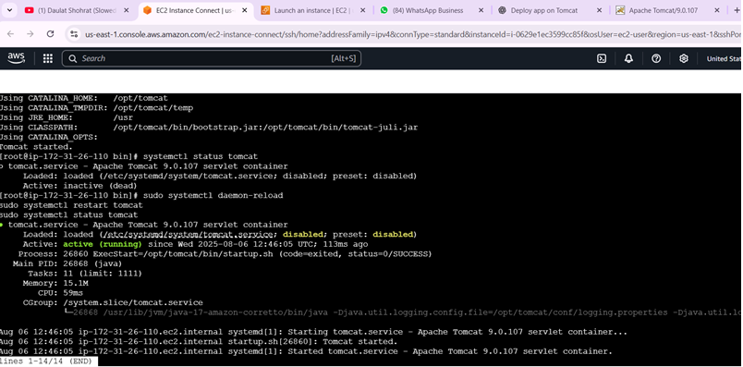

commands
yum update
yum install java-17 -y
cd opt
wget https://dlcdn.apache.org/tomcat/tomcat-9/v9.0.107/bin/apache-tomcat-9.0.107.tar.gz
tar xvf tomcat.tar(extract file)
mv tomcat-file-name tomcat
chown -R ec2-user:ec2-user tomcat
chmod 777 /opt/tomcat/bin/startup.sh shutdown.sh
touch /etc/systemd/system/tomcat.service
vi tomcat.service(paste the code)
----------------------------------------------------------------
[Unit]
Description=Apache Tomcat 9.0.107 servlet container
After=network.target

[Service]
Type=forking

User=ec2-user
Group=ec2-user

Environment=JAVA_HOME=/usr/lib/jvm/java-17-amazon-corretto
Environment=CATALINA_HOME=/opt/tomcat
Environment=CATALINA_BASE=/opt/tomcat
Environment=CATALINA_PID=/opt/tomcat/temp/tomcat.pid

ExecStart=/opt/tomcat/bin/startup.sh
ExecStop=/opt/tomcat/bin/shutdown.sh

Restart=on-failure
TimeoutSec=30

[Install]
WantedBy=multi-user.target
------------------------------------------
sh startup.sh
systemctl daemon-reload(to give daemon permissions)
systemctl status tomcat
systemctl start tomcat
(hence we can access the tomcat by using systemctl command)

- Configure HA Proxy server.
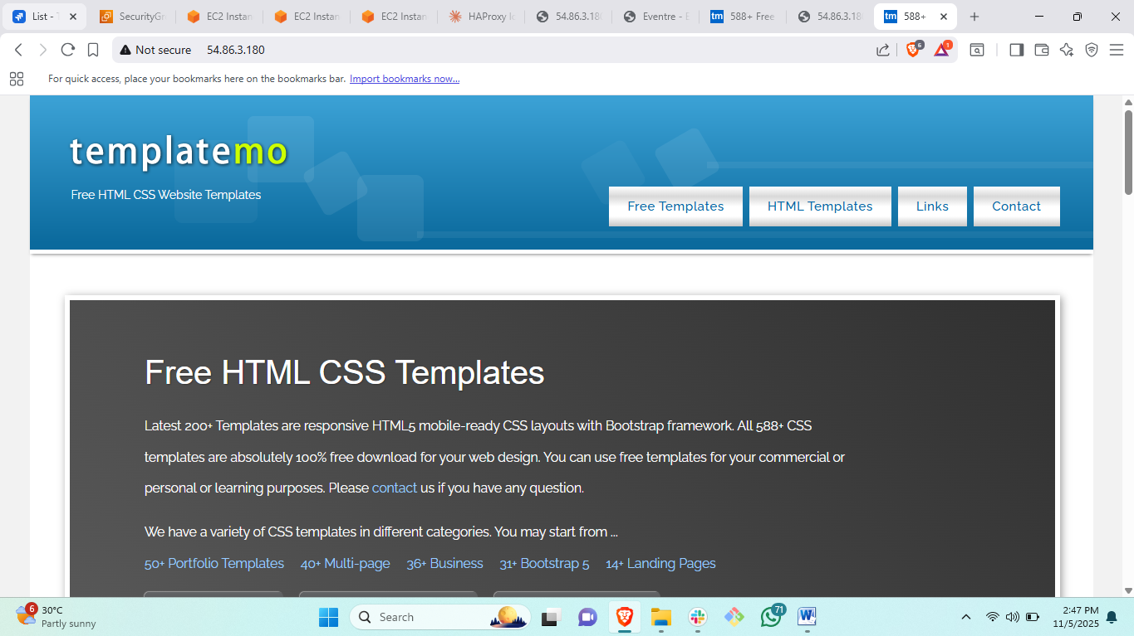

Steps: first create a haproxy server and allow security credential all traffic.
# copy haproxy public ip and go to nginx-server and paste in #vi /etc/hosts.
#go to apache httpd-server and paste public ip of haproxy #<vi /etc/hosts>
#copy both nginx and httpd public ip and go to haproxy server paste ips in <vi /etc/hosts>
#then install haproxy in proxy server<yum install haproxy>
# <systemctl start haproxy>
#<systemctl enable haproxy>
#<systemctl status haproxy>
#then go to <cd /etc/haproxy/>
# edit file called haproxy.cfg.
#copy both ips of nginx and httpd along with port nuber :81 or :82
#Change the bind from :5000 to 80
To check the status copy haproxy public ip and search in browser.

